Before the Cloud-

We need to Server

If we have Server mean

* Have to Buy it
* Have to install it
* Have to Maintain
* Have to Replace
* Have an IT team

And other problem is lot of wasted money going for unused computer power.

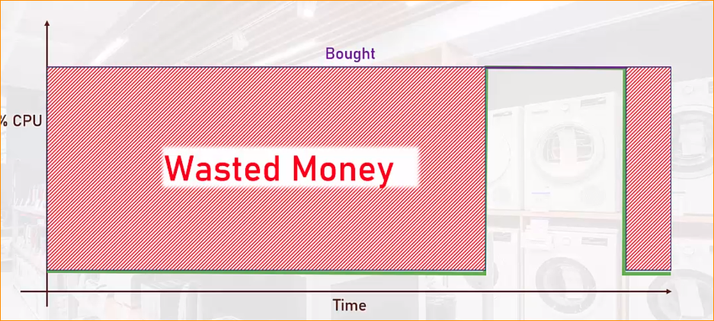

**Cloud –**

**Is Compute, Networking, Storage and other services Manage by Someone else.**

Cloud Providers?

* Companies that build huge data centers
* Fill it with Servers, networking, cooling, electricity
* Design and install various services
* Make it publically accessible.

Ex- Microsoft Azure Data center

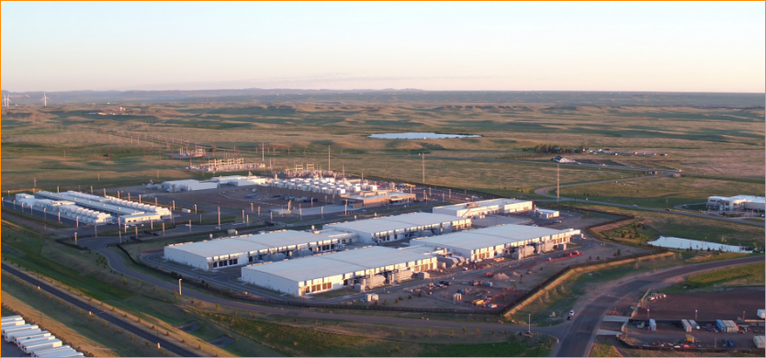

Cloud are huge and the competition is fierce.

Offer a lot of additional sevices- AI, IOT , Kubernets and more.

So If you need Server –

* Create it in the cloud within mimutes
* Use it as you wish
* Pay fro what you use
* Shut it down when you not need
* Automatically maintained patched secured, monitored.

1. **Characteristics of Cloud Computing**
2. On Demand Self Service –

* no human interaction is needed for resource provisioning.
* Just click button and create.
* This provisioning available 24x7

1. Broad NetWork Access –

* Resource can be accessed from anywhere using the network,
* ideally high broadband,
* no Physical access to anytime

1. Resource Pooling

* Physical resources are shared between customers.
* The cloud back bone decide to allocate for a customer's virtual service.
* Some advance cloud service allow fro physical resource separation.

1. Rapid Elasticity-

* Resource can be scaled up and down as needed, automatically.
* No need to purchase resources for a one-time scenario.

1. Measured Service –

* payment is done only for resources actually used.
* Paying for server time/Db storage / Function calls.
* Measurement is usually done in high-resolution,
* No need to invest money in non-used resources.

**CapEx and OpEx**

CapEx- Capital Expense (Making upfront investment fro future use/ profit)

* Traditional IT- CopEx ( Building data center, purchasing servers, air conditioning, network devices, software licenses) after all this finally can use it.

OpEx- Operating Expense (Paying for actually what we used)

* Traditional IT- OpEx (Electricity, Salaries for IT guys, Maintenance)

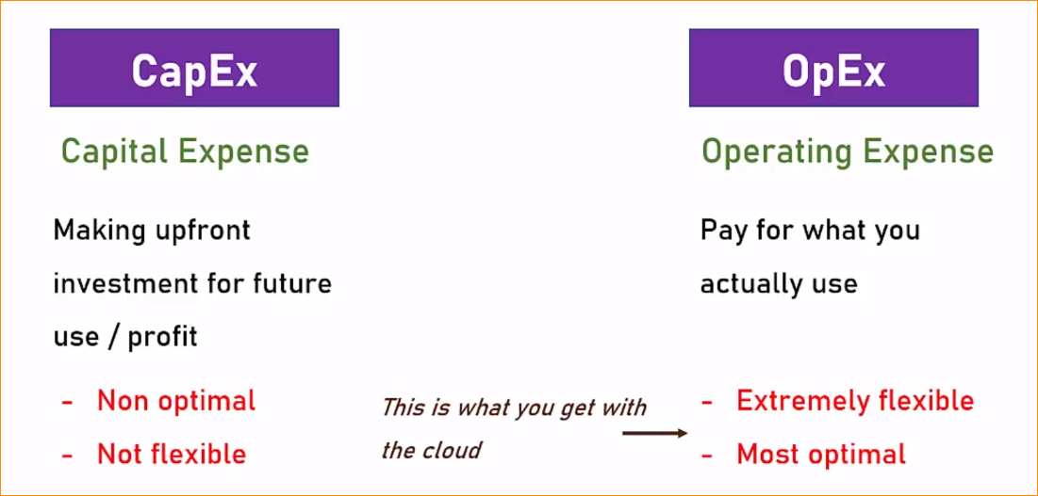

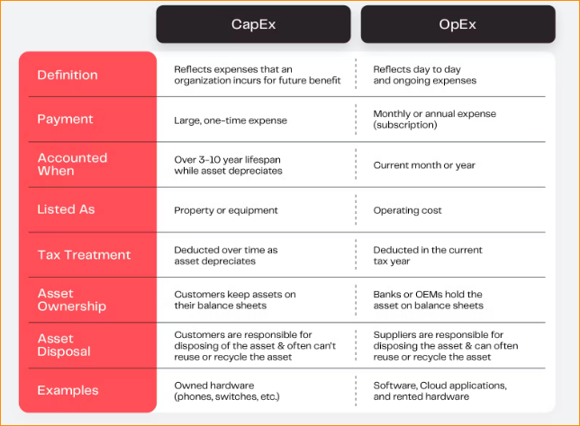

**Types of Cloud Service-**

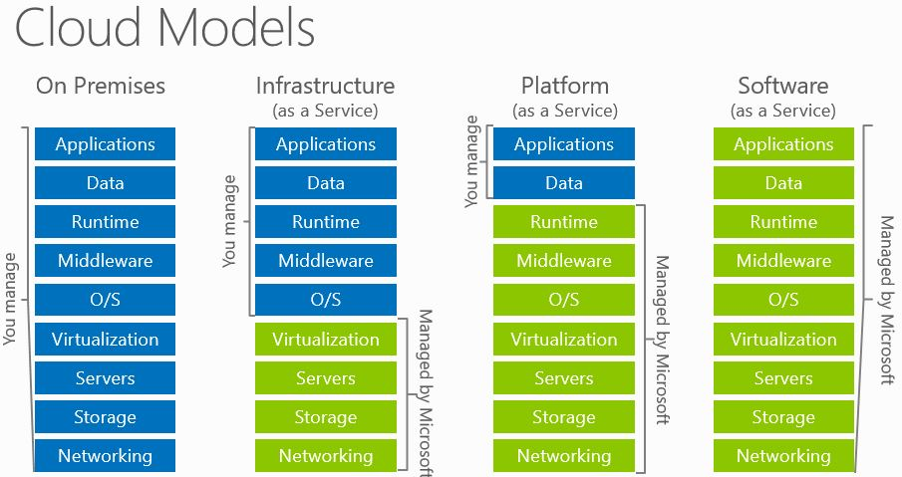

IaaS – Infrastructure as a Service

* The cloud provides the underling platform (Compute, Networking, Storage)
* the client handles and responsible for all the rest .
* Common Example – Virtual machines
* VM- the cloud provides the host machine, networking and disks.
* The client create the virtual(guest) machine, installs, software on it, patches it, maintain it.

PaaS – Platform as a Service

* Cloud provides a platform for running apps
* Including -- Compute, Networking, Storage runtime environment, Scaling, Redundancy, Security, updates, patching , maintenance.
* The client just need to bring the code to run
* So thing is develop our software and upload to cloud,
* Example – Web Apps (Cloud provides the run time for running web apps, Client only upload the code and just runs)
* Client hasn’t access to the underlying Virtul machine.

SaaS – Software as a Service

* Running completely in the cloud
* User doesn’t need to install anything on-premises or on his machine
* The provider handle all, we just use and no access to Infrastructure.
* Example – Office 365 , salesforce with are installed in the cloud.
* We have no idea what are the Infrastructure running on or what language are they developed in or database. We just use it.

**Additional services –**

1. FaaS (Function as a Service):

* FaaS is a cloud computing model that allows developers to build, run, and manage application functionalities without the complexity of building and maintaining the infrastructure typically associated with developing and launching an app.
* Examples include AWS Lambda, Azure Functions, and Google Cloud Functions.
* With FaaS, developers can focus on writing code for discrete functions or pieces of business logic without worrying about server management.

1. DBaaS (Database as a Service):

* DBaaS refers to a database management system that is hosted and managed by a third-party provider in the cloud.
* It allows users to access a database without having to set up physical hardware, install software, or configure it for performance.
* Examples include Amazon RDS, Google Cloud SQL, and Azure SQL Database.

1. DaaS (Desktop as a Service):

* DaaS is a cloud computing offering in which a third-party provider hosts virtual desktops on their infrastructure and delivers them to users over the internet.
* It allows businesses to deliver desktops to end-users without the need for on-premises infrastructure.
* Examples include VMware Horizon Cloud and Amazon WorkSpaces.

1. IoTaaS (Internet of Things as a Service):

* IoTaaS refers to the provision of IoT solutions as a service, allowing businesses to deploy, manage, and analyze IoT devices and data without the need for extensive upfront investments in infrastructure and expertise.
* It provides a scalable and flexible platform for connecting, managing, and analyzing IoT devices and data.
* Examples include AWS IoT Core, Microsoft Azure IoT Suite, and Google Cloud IoT.

1. AIaaS (Artificial Intelligence as a Service):

* AIaaS refers to cloud-based platforms that provide AI capabilities as a service, enabling developers and businesses to leverage AI technologies without the need for deep expertise in AI or extensive infrastructure.
* It offers a range of AI services, such as machine learning, natural language processing, computer vision, and more, through APIs or managed services.
* Examples include AWS AI Services (e.g., Amazon SageMaker, Amazon Comprehend), Google Cloud AI Platform, and Azure AI services.

**Types Of Cloud-**

Public Cloud –

* The cloud is set up in the public network
* Managed by large companies
* Accessible through the internet
* Available to all clients and users
* Clint haven’t access to underline infrastructure.
* Example – AWS, Azure, Google cloud, IBM Cloud, Oracle cloud, Ali cloud So on

Private Cloud –

* A cloud set up in an organization premises
* Manage by the organizations IT team
* Accessible only from the organization’s network
* Available to users from the organizations
* Uses private cloud infrastructure and engines
* Contains subset of the public clouds capabilities
* This use for security reasons.
* Example – VmWare Cloud, Azure Stack

Hybrid Cloud –

* A cloud set up in an organization premises but also connected to the public cloud.
* That mean Workload can be separated between the two clouds
* Example – Sensitive data in the organization premises , public data in the public cloud. (Oraginasation’s users credit card details store in the private cloud and user’s linkin details store in public cloud )
* Azure Arc and AWS Outposts

**Main Cloud Providers –**

* Companis that build data centers and provide public cloud services. Such as (IaaS, PaaS,And SaaS, other services)
* Top 3 main Colud services providers – AWS , Azure and Google
* Azure Is the fastest growing public cloud fro years.